GF Cinnamon Banana Crockpot Cake
(you won’t believe it’s gluten free)

If you're a haphazard hostess like me, this simple cake will keep your secret. Snag your 4.5-quart crockpot and let's get going.

Ingredients:
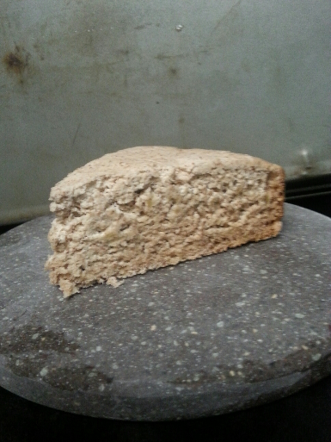
The Dry:
1 3/4 cups of gluten free flour
1 ¼ tsp xanthan gum (unless it's included in your GF flour)
2 tsp baking powder
½ tsp salt
1/4 tsp baking soda
2 tsp cinnamon
The Wet:
1/3 cup of butter
2/3 cup of sugar
2 eggs
2 tbsp. honey
1 tsp vanilla
3 ripe bananas (mashed to your delight)

How it works:
Grease and flour your crockpot. (I use spray and almond flour)
In a small bowl, mix up your dry ingredients. Set it aside. In a medium bowl cream your butter with an electric mixer, making it nice and fluffy. Add in your sugar and eggs, mix again. Then add your honey, vanilla, and the bananas. Mix again. Slowly add your dry mixture to the creamy mixture. (Smell the cinnamon and add more if you're a cinnamon lover)
Pour into the crockpot. Slightly smooth the top of your batter. Put the lid on your crockpot and cook on high for 75-90 minutes or until you can poke it with a toothpick and it comes out clean. (depending on your crockpot it can take closer to 2 hours)
Let it cool slightly then invert it onto a plate or platter. Enjoy warm with butter sliding off the top or cold with a hot mug of yumminess.

Love from Sarah the Coffee Jedi

